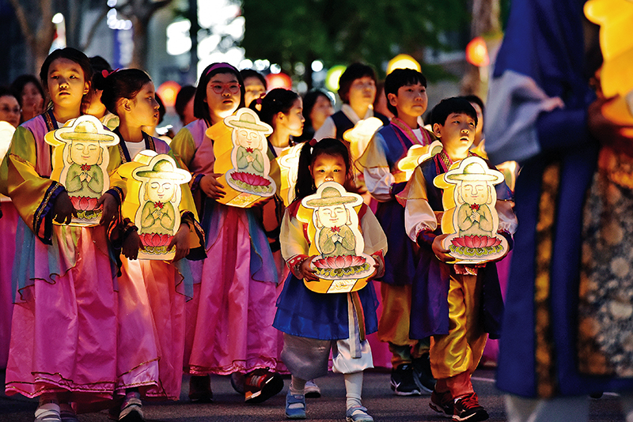

Registration Form for International Guests:

Lantern Parade Event
Office of  International Dharma Instructors' Association  - EMAIL  idia.seoul@gmail.com  - PHONE  82-2-722-2206  fax  82-2-722-2203  - google Form : https://forms.gle/EFB8ZVNwTSGRi9mm7  - MS.HONG  - 010-9980-6120  - MS.LIM.  - 010-9115-3642 |  | ▶ Please complete this form and send it by E-mail, Fax or Google form.  ▶We will accept it on a first come, first served basis  If there are many applicants, it will be closed early..  - Last name: __________First name: __________________  Nationality: __________E-mail: _______________________  Cellular phone:______________________________________  - Last name: __________ First name: ________________  Nationality: __________  - Last name: ___________ First name: __________________  Nationality: ____________  - Last name: ___________ First name: __________________  Nationality: ____________  ▶Please select from below and also the child(ren)’s age are needed in order to prepare the seats accordingly.  ( ) will watch the parade only  ( ) at the end of parade, will march in the Lantern Parade.  ●Total number(adults: children: ) Ages of children( , )  ▶ Please note that your photos can be taken during this event for promotional purpose and your personal information is for this event only.  ▶Your personal information will only be used for the purpose of the event

